**Cloud Computing Lab Nayab Khazin**

**BSE-V B**

**2023-BSE-046**

**LAB 13**

# Task 0 Lab Setup (Codespace & GH CLI)

* task0_codespace_create_and_list.png

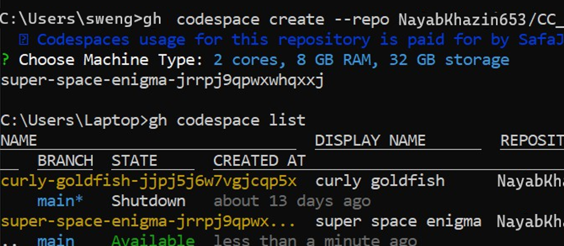

* task0_codespace_ssh_connected.png

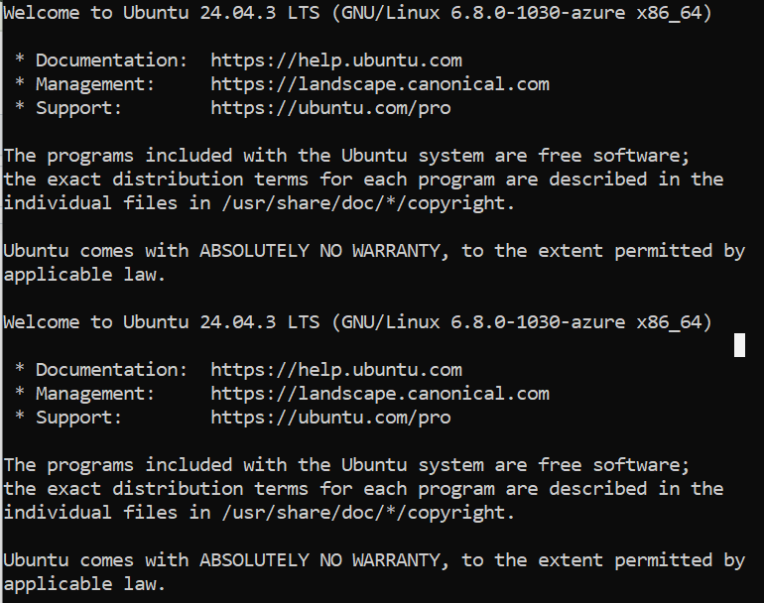

# Task 1 — Create IAM Group and Output Details

* task1_project_directory.png



* task1_file_created.png



* task1_main_tf.png

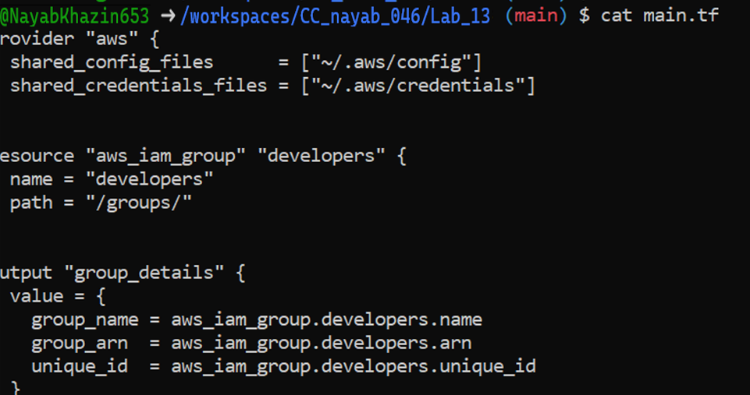

* task1_terraform_init.png

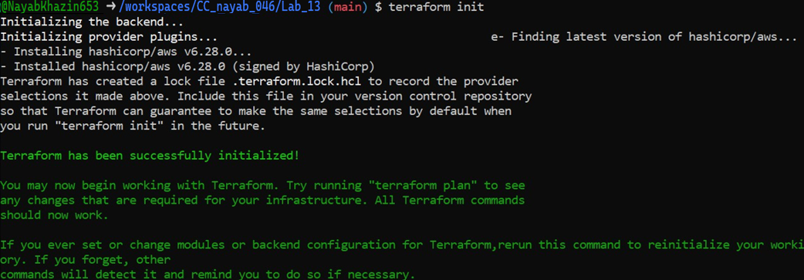

* task1_terraform_apply.png

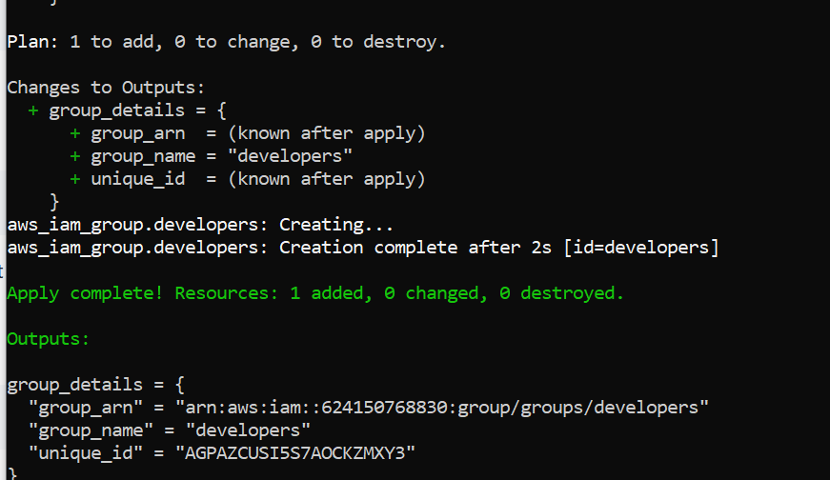

* task1_terraform_output.png

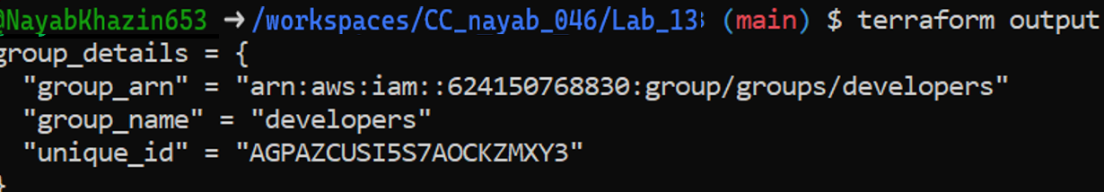

* task1_aws_console_group.png

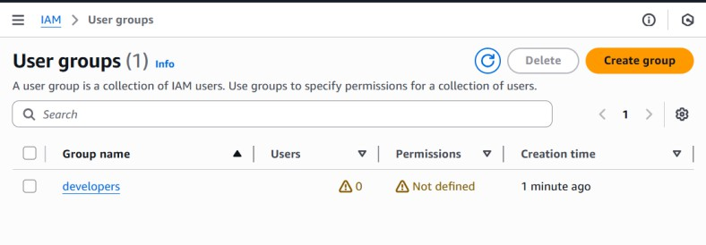

# Task 2 — Create IAM User with Group Membership

* task2_main_tf_user.png

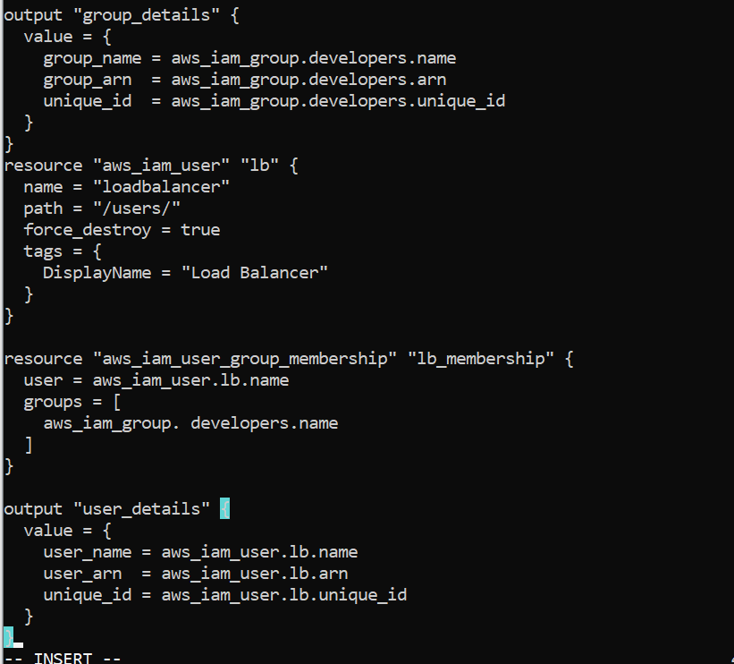

* task2_terraform_apply.png

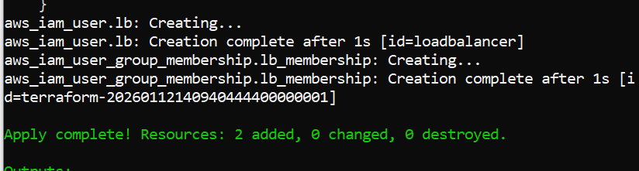

* task2_terraform_output.png

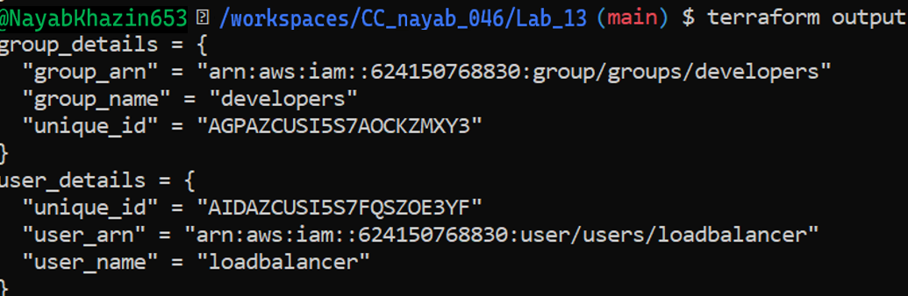

* task2_aws_console_user.png

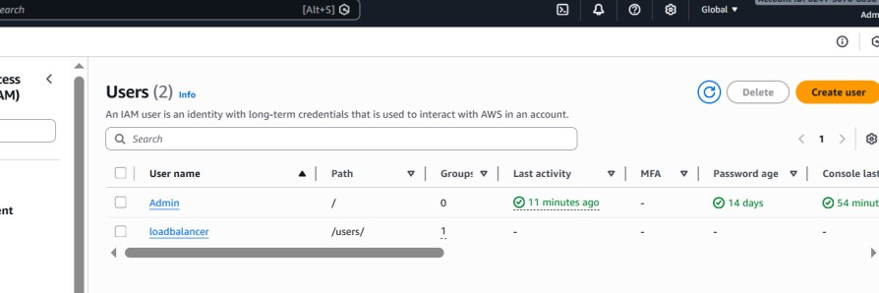

* task2_aws_console_user_groups.png

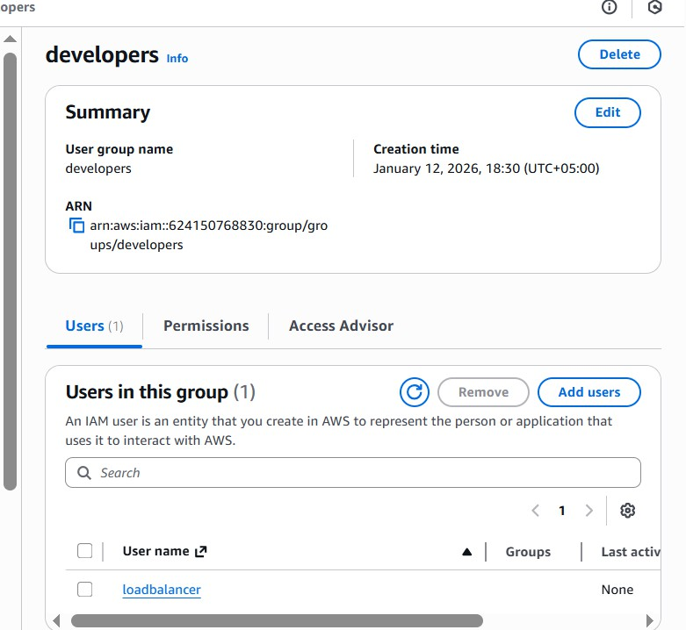

# Task 3 — Attach Policies to IAM Group

* task3_main_tf_policies.png

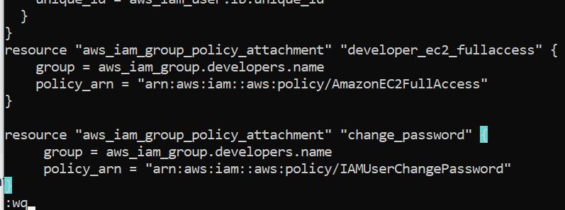

* task3_terraform_apply.png

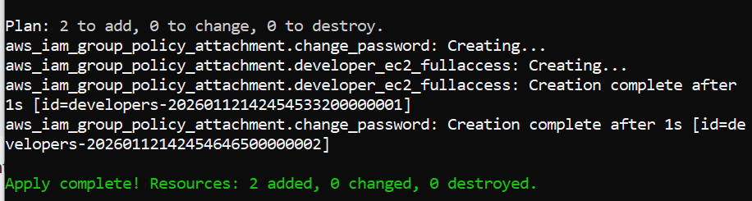

* task3_aws_console_policies.png

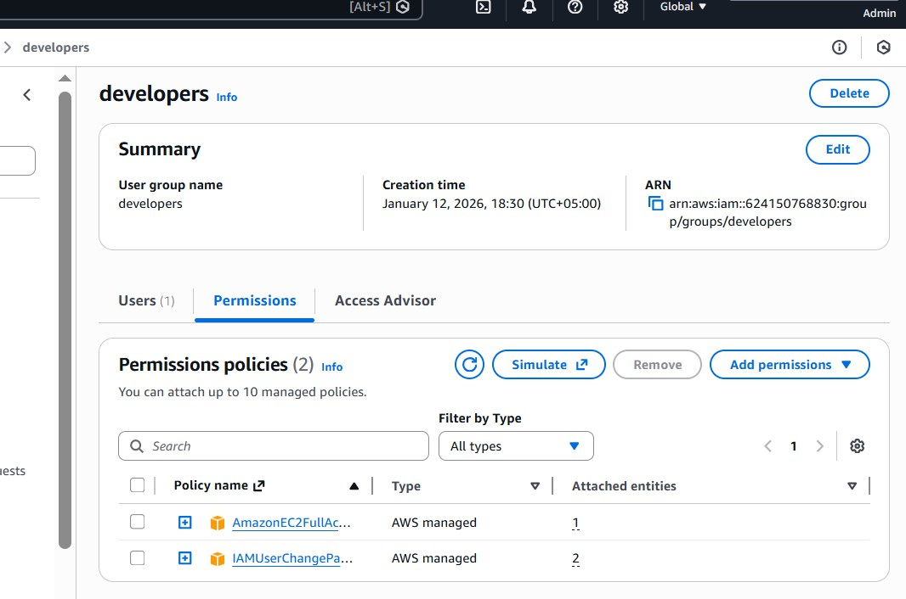

# Task 4 — Create Login Profile for IAM User

* task4_variables_tf.png

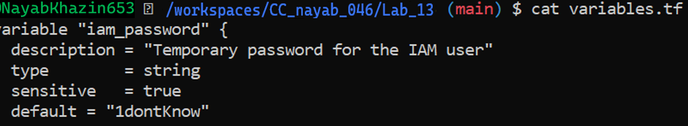

* task4_create_login_script.png

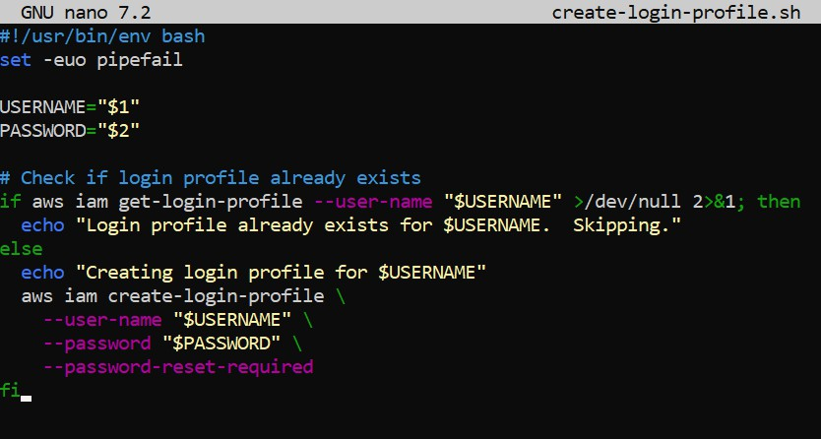

* task4_chmod_script.png



* task4_main_tf_login_profile.png

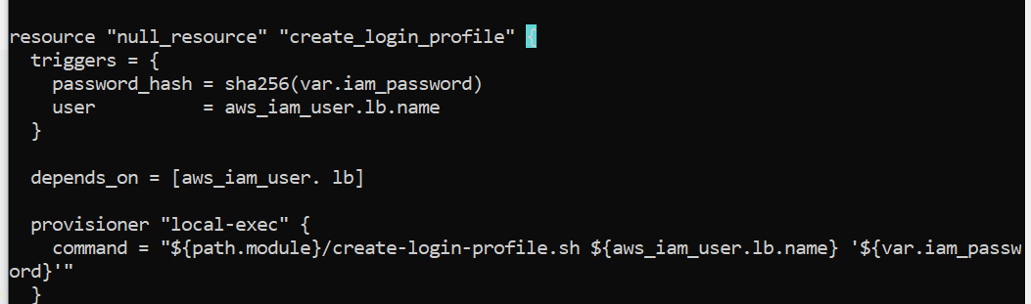

* task4_terraform_apply.png

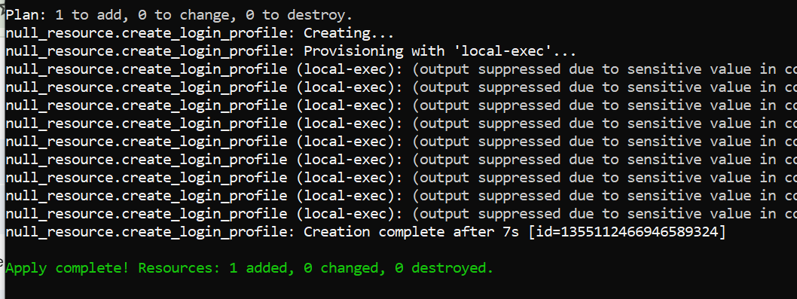

* task4_aws_cli_verify.png

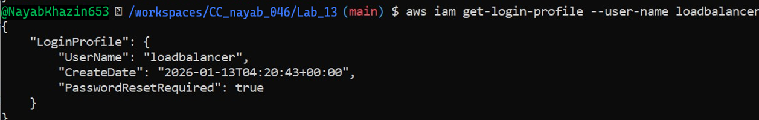

* task4_aws_console_login.pn

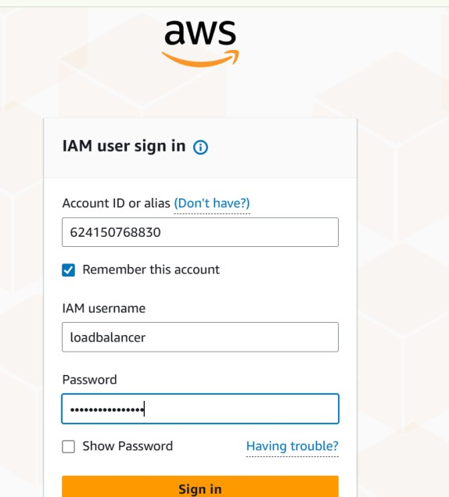

* task4_aws_console_password_reset.png

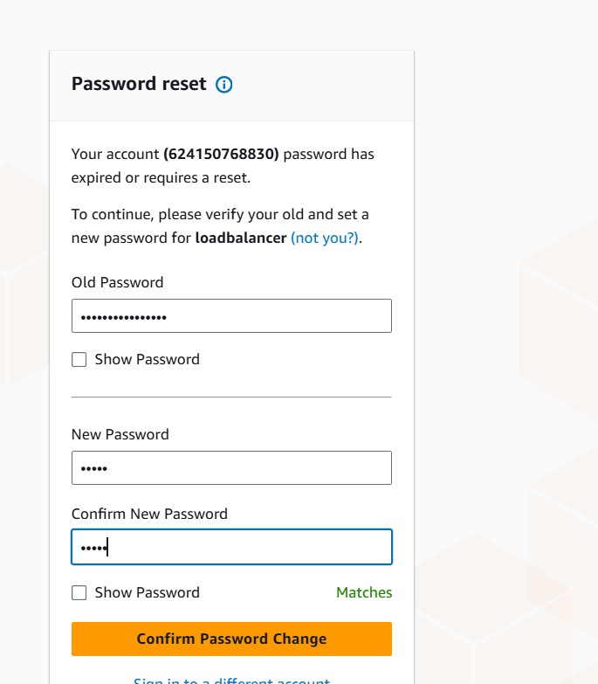

# Task 5 — Generate Access Keys for IAM User

* task5_main_tf_access_keys.png

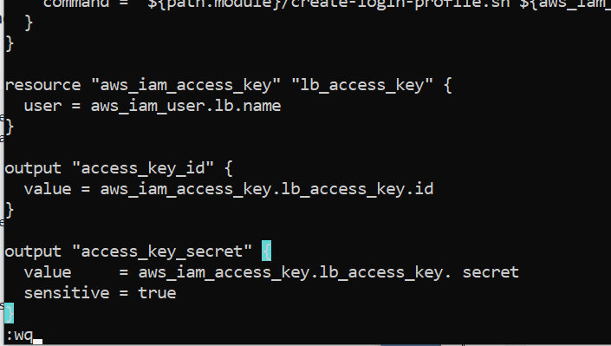

* task5_terraform_apply.png

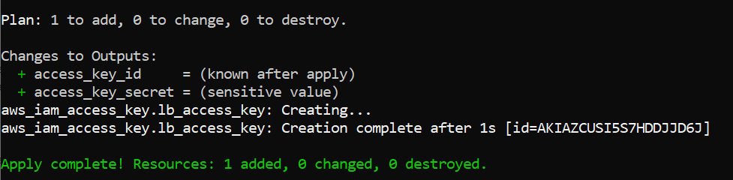

* task5_terraform_output.png

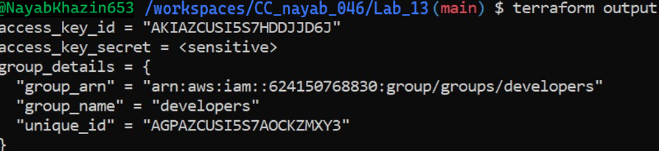

* task5_tfstate_secret. Png

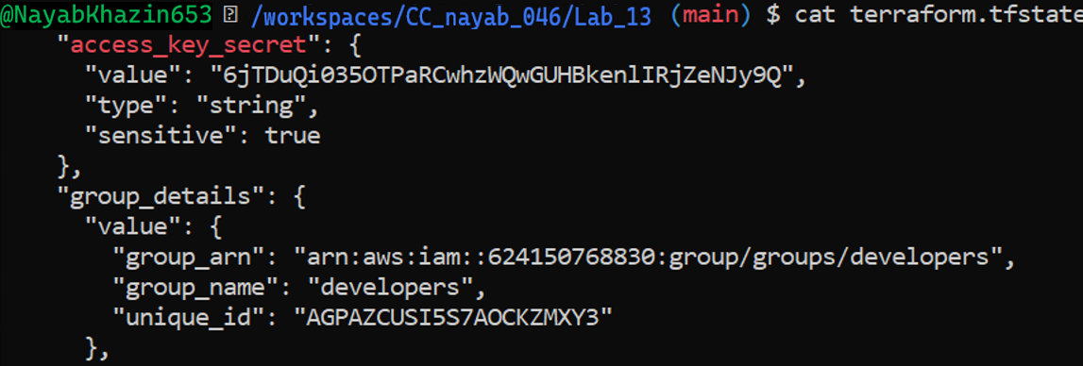

* task5_aws_console_access_keys. Png

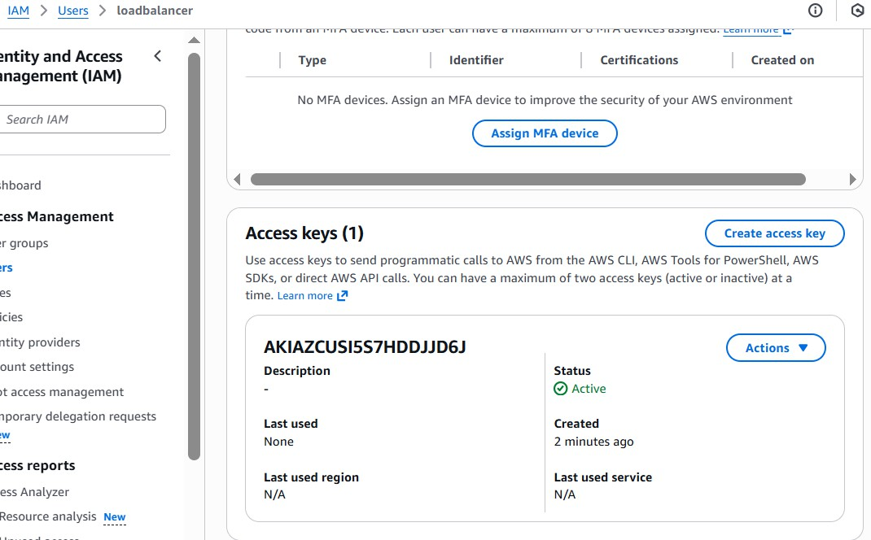

# Task 6 — Implement Terraform Remote State with S3

* 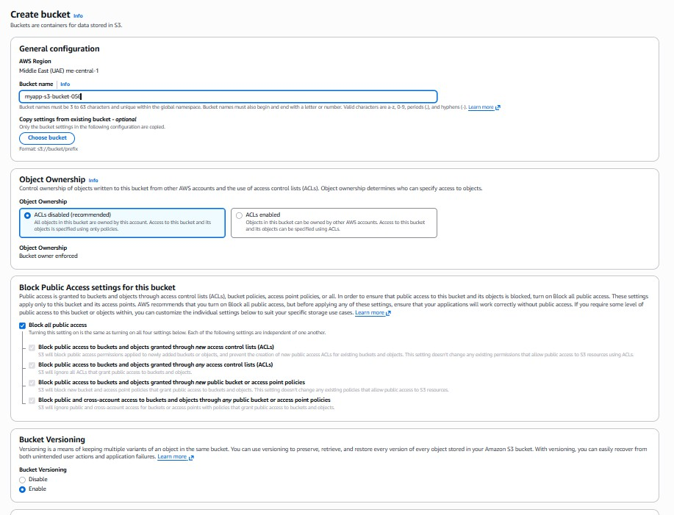task6_s3_bucket_create.png
* task6_s3_bucket_versioning.png

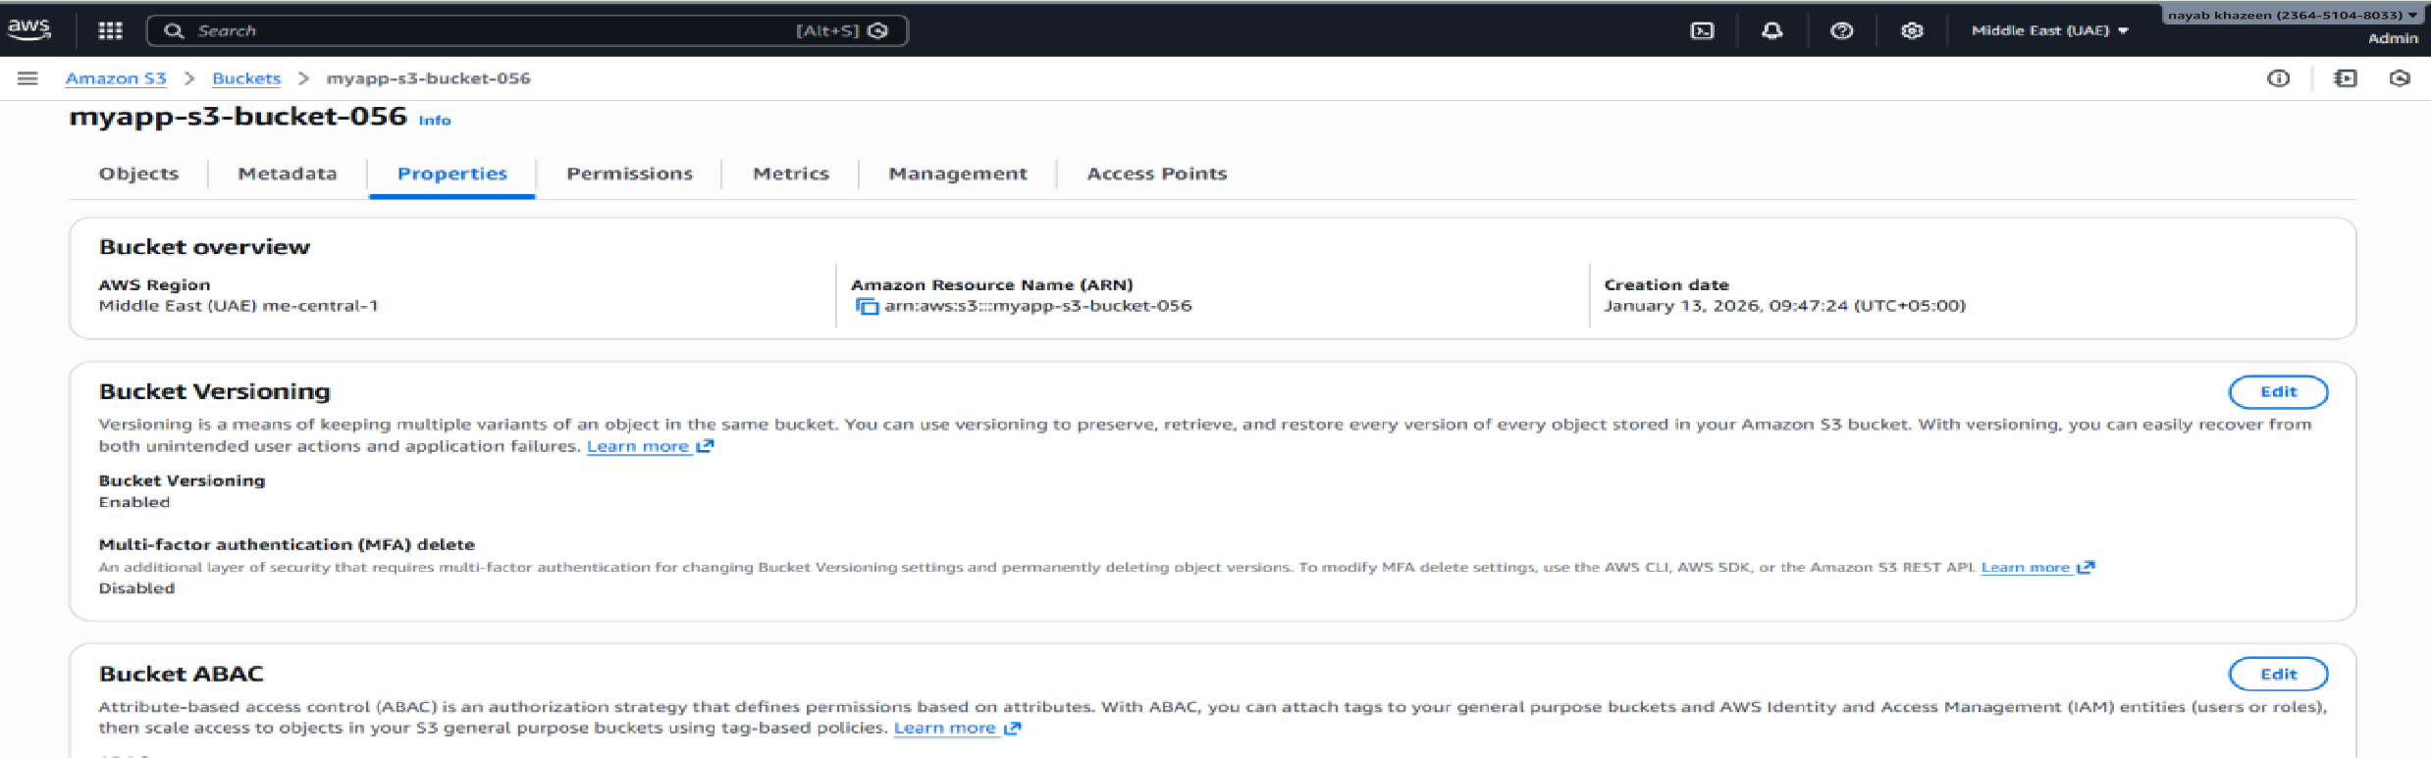

* task6_main_tf_backend.png

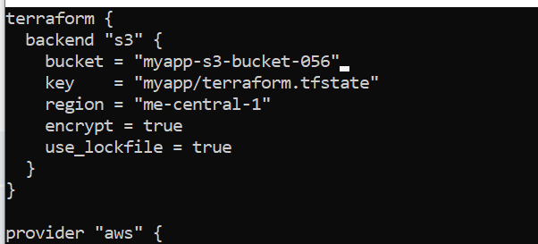

* task6_terraform_init_migrate.png

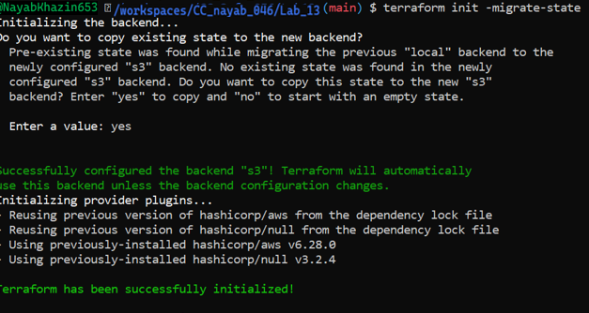

* task6_terraform_apply.png

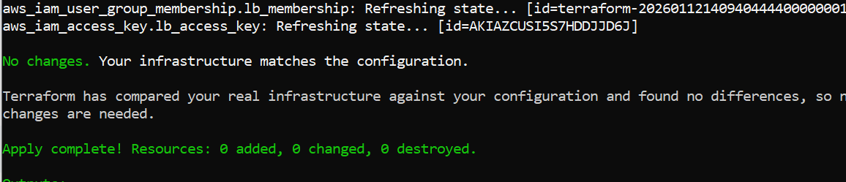

* task6_s3_tfstate_file.png

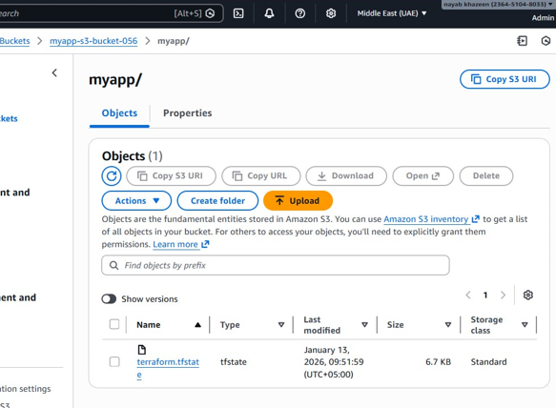

* task6_local_state_backup.png



* task6_terraform_destroy.png

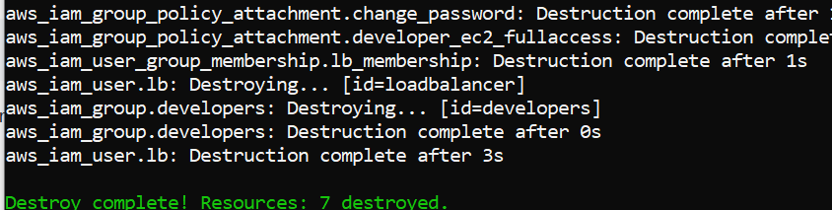

* task6_s3_tfstate_destroyed. Png

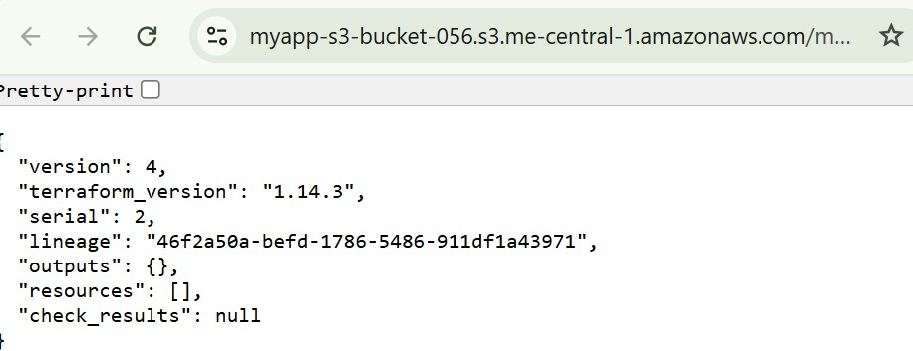

# Task 7 — Create Multiple Users from CSV File

* task7_locals_tf.png

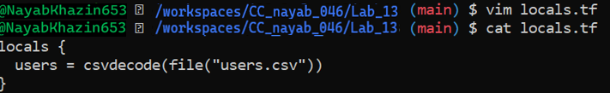

* task7_users_csv.png

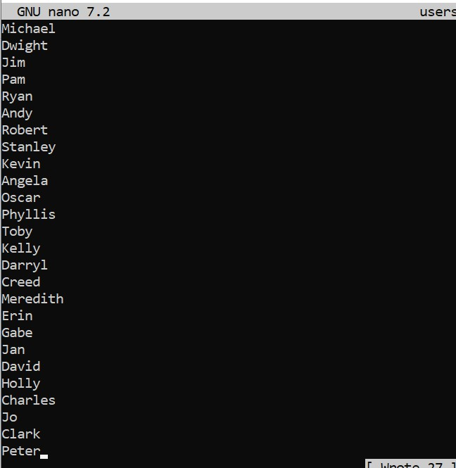

* task7_main_tf_multiple_users.png

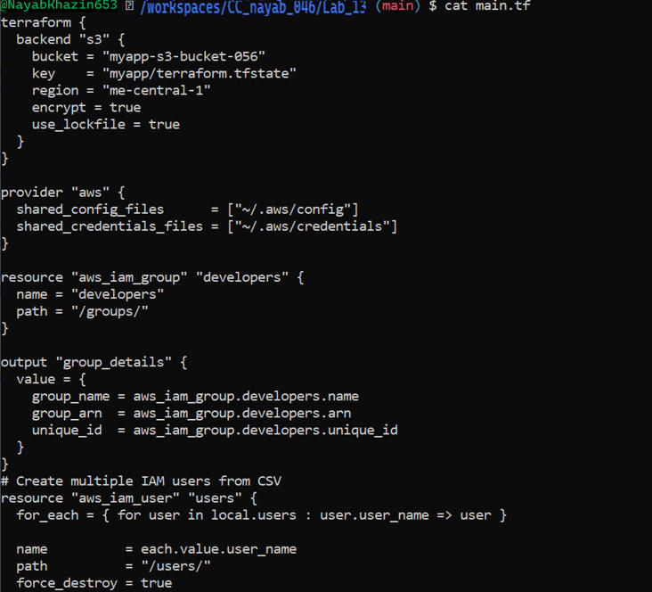

* task7_terraform_init.png

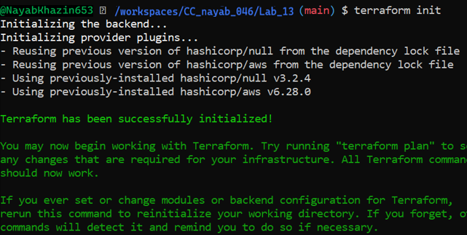

* task7_terraform_apply.png

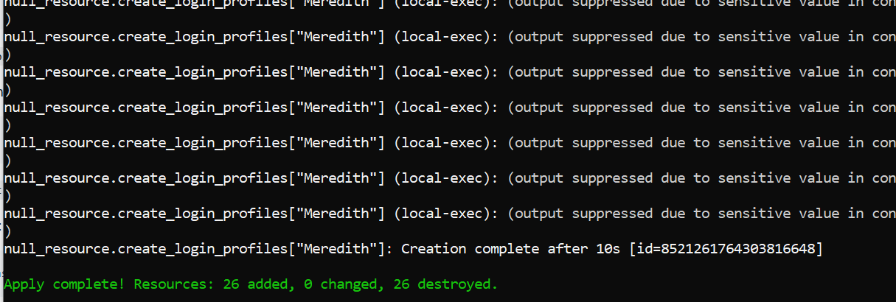

* task7_terraform_output.png

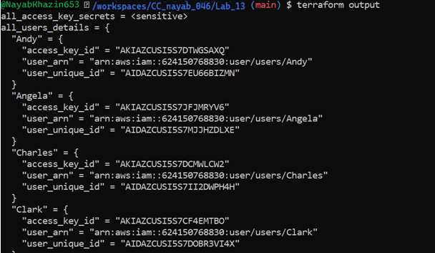

* task7_tfstate_secrets. Png

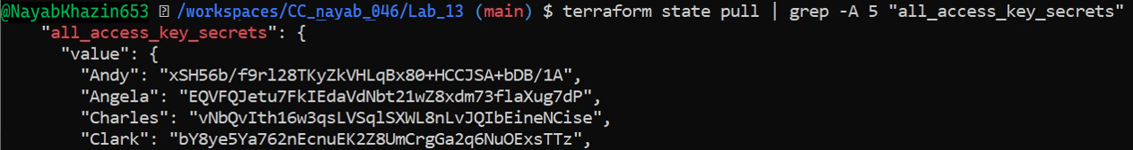

* task7_aws_console_all_users. Png

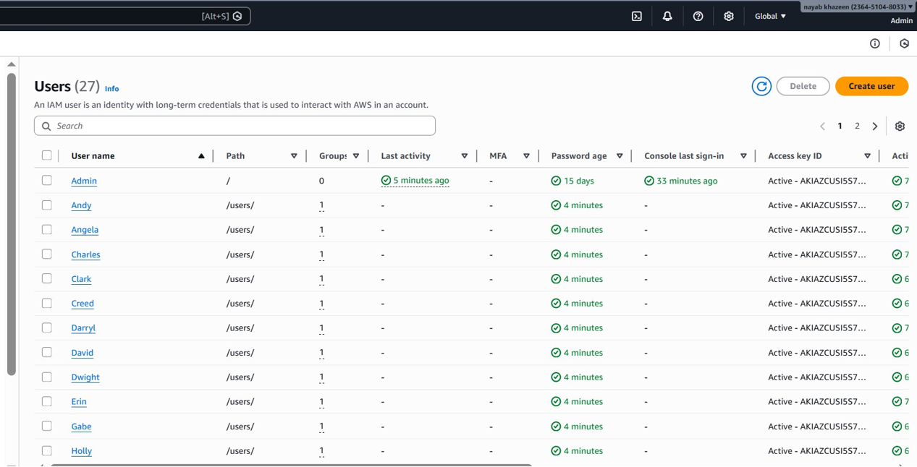

* task7_aws_console_group_members.Png

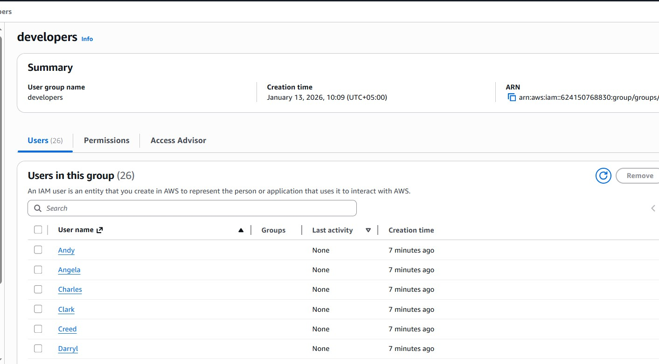

* task7_aws_console_user_access_key.png

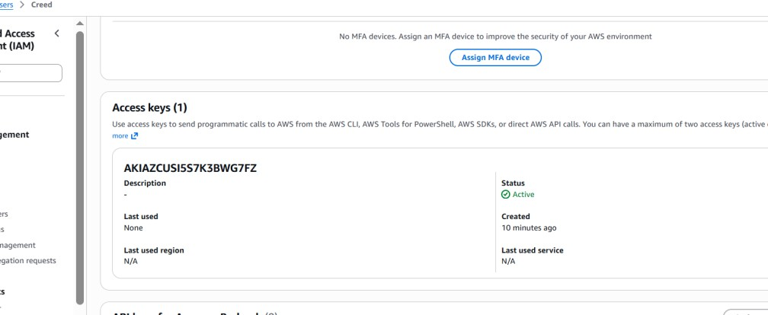

* task7_s3_tfstate_multiple_users.png

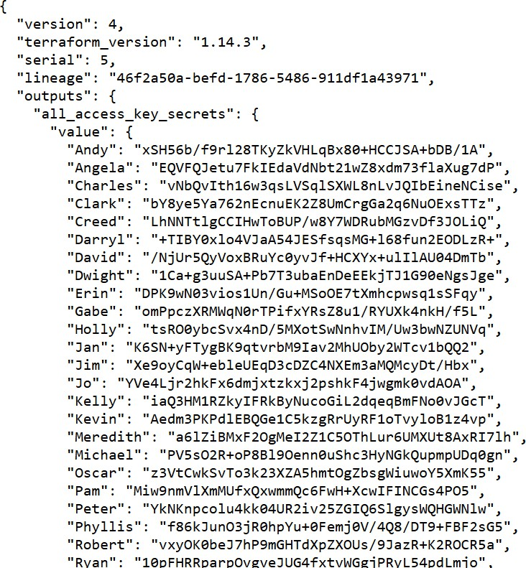

# Cleanup

* cleanup_destroy_complete.png

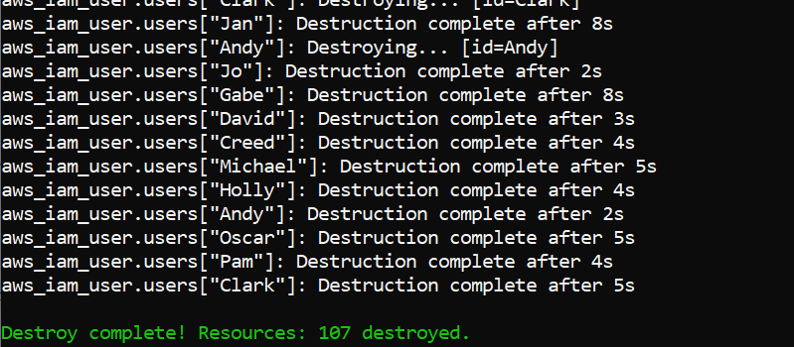

* cleanup_aws_console_users_deleted.png

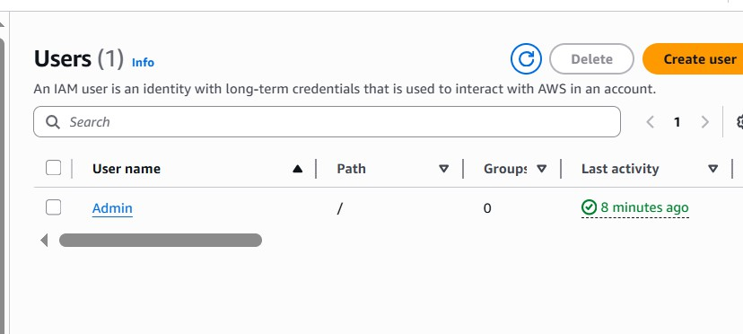

* cleanup_aws_console_group_deleted.png

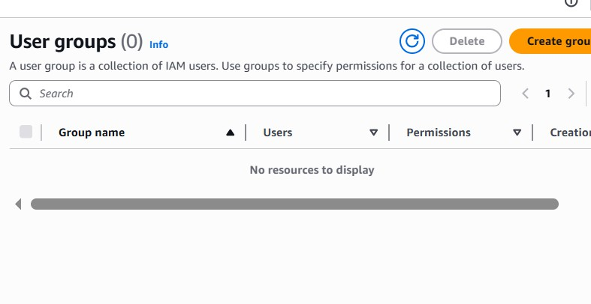

* cleanup_s3_empty_state.png

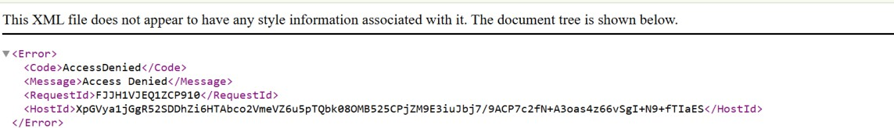

* cleanup_final_files.png

